Headway Wearside
Improving Life after Brain Injury

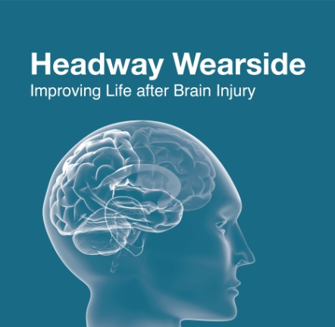
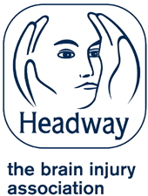
Annual Report
2019 – 2020
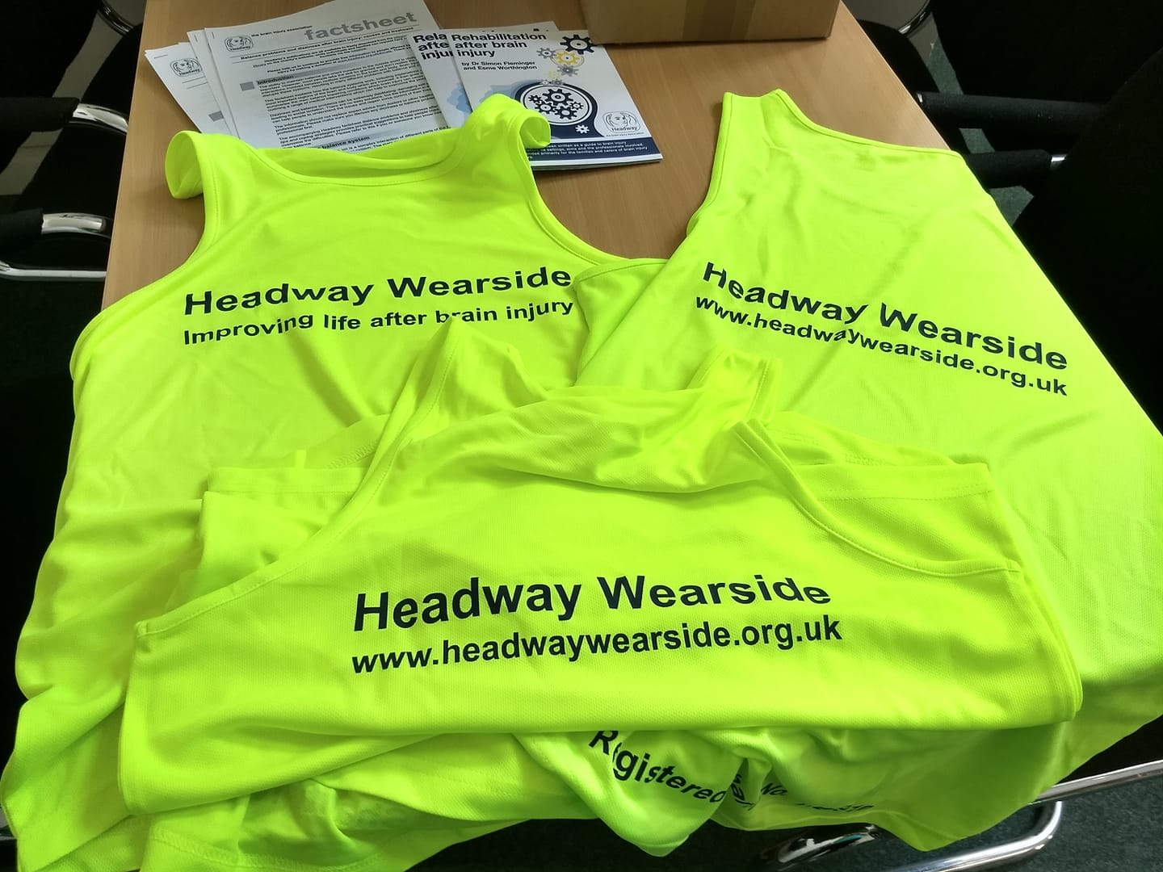

Headway Wearside is Registered under Charity Number: 1140910 and a company limited by guarantee registered in England no 07504702
“Affiliated to Headway UK, the brain injury association ”

Welcome
Headway Wearside is a registered charity and company limited by guarantee, it is affiliated to Headway UK the national brain injury association.

Headway Wearside was formally launched on 24th November 2009, by the Mayor of Sunderland at the Stadium of Light in Sunderland.

Who is it for?
Headway Wearside is open to anyone with an acquired brain injury, their family members and carers or health and social care professionals with an interest in acquired brain injury.

What is an Acquired Brain Injury?
The term ‘acquired brain injury’ or ‘ABI’ includes traumatic brain injuries, such as open or closed head injuries, or non-traumatic brain injuries, such as those caused by strokes and other vascular accidents, tumours, infectious diseases, hypoxia, metabolic disorders (e.g. liver and kidney diseases or diabetic coma), and toxic products taken into the body through inhalation or ingestion.

Acquired Brain Injury is known as the ‘Hidden Disability’ and people rarely realise the challenges that caring for a person with a brain injury can bring. Living with an Acquired Brain Injury can mean having to cope with mobility difficulties, memory loss, extreme fatigue, cognitive and behavioural difficulties and personality changes. We often hear brain injury survivors describing themselves as being ‘completely different people’ following their injury.

Aims of the organisation
Headway Wearside aims to provide information, support and social activities for brain injury survivors, their families and their carers in Sunderland and surrounding areas.

We aim to provide support and social activities to individuals who have an acquired brain injury in order to promote and increase social independence and in turn reduce isolation and issues relating to depression, anxiety and reduced confidence.

We hope to increase the confidence of those who have an acquired brain injury to enable them to take part in their community. This in turn will hopefully help them to feel safe in their community thus increasing their feeling of wellbeing.

We aim to reduce the stigma often experienced by those who have an acquired brain injury by raising public awareness of issues surrounding brain injury.

We provide signposting and information about local services for brain injury survivors, their families and carers.

What does Headway Wearside do?

The unique combination and variety of problems faced by individuals with Acquired Brain Injury frequently leads to isolation and the inability to access appropriate services.

We are a person-centred organisation, so instead of telling our group members what to do, we aim to empower and enable people by supporting them to develop their skills and abilities to cope better with the difficulties which arise from having an acquired brain injury.

Therefore at Headway Wearside we aim to offer the following:

- To increase awareness of brain injury and its consequences
- To initiate activities and campaigns which will reduce the incidence of brain injury
- To provide information and support for people with acquired brain injuries, their relatives and carers and concerned professional people
- To promote improved approaches to acquired brain injury screening, acute care, assessment, rehabilitation and social re-integration
- To assist people with acquired brain injuries to return to community living, including access to appropriate accommodation, social outlets, and productive activity
- To Signpost people to relevant local services for persons with an acquired brain injury
- To hold regular social meetings and activities so people with acquired brain injuries, their relatives and carers can come together to take part in a range of activities that they themselves choose.
- Facilitate social opportunities for members to attend regional and national Headway events and meet with other members
- Provide volunteering opportunities and enable supporting professionals to come together to support its members
- Break down barriers of discrimination by working with local groups and individuals to dispel any myths or issues about acquired brain injury.

Who can be referred to Headway Wearside?

Referrals must be for someone who has had an acquired brain injury (ABI).

Anyone can make a referral to Headway Wearside and we will consider all referrals whether from a health care professional, social worker, family member, carer or self-referral.

The person being referred should be at least 18 years of age. If the person is under 18 you may want to contact the Child Brain Injury Trust (CBIT) (see www.childbraininjurytrust.org.uk)

To make a referral please contact Kim Hunter Business and Community Development Officer on 0191 522 7113 / 07830346985, Email kim.hunter@headwaywearside.org.uk

Chair Persons Report 2020

I am delighted as Chairperson for the charity to say that despite a number of challenges Headway Wearside has continued to develop and grow the range of services and support, we offer to our members.

The AGM report provides a details of the various initiatives we have ran over the last twelve months. However in our 10th year as a charity I would just like to pay tribute to all the volunteers who have supported the charity either through being part of the committee, mentoring other members or by fundraising for the charity.

I must pay particular tribute to the work carried out by Kim Hunter our fantastic Business and Community Development worker to whom as a committee we are extremely grateful. This is a role that Kim has been involved with for many years and the successes of the charity have been in a large part because of her drive and commitment.

I must also pay tribute to Charlotte O’Keefe who has continued to work tirelessly for Headway Wearside within the NHS for the Sunderland and Gateshead Community Acquired Brain Injury Service (CABIS). This role is something which shows Headway Wearside’s commitment to working collaboratively to support brain injury survivors and their families and carers in the Sunderland and surrounding areas.

As a charity we continue to engage with our members and we have a number of Brain Injury survivors, carers and family members on our committee who volunteer their time and ensure that we are delivering activities and support that our members need. This holistic person centred approach is an important part of the charities business plan.

As many of you will note Headway Wearside depends upon ongoing funding from various sources including charitable trusts, individual fundraising, company fundraising and most importantly ongoing funding from Sunderland City Council and the Sunderland Clinical Commissioning Group (CCG). We are therefore very thankful for the financial support we have received.

Headway Wearside has secured additional funding towards the salary of Kims role as Business and Community Development Worker for 2019 - 2021 from the Peoples Health Trust.for a 17 month programme. The aim of which will be to continue to build the membership, increase volunteer opportunities, continue to develop activities and support the Committee in securing additional funding.

I would therefore like to pay special tribute to all those that have been involved in fundraising for Headway Wearside. I would welcome anyone who is thinking of fundraising for us to please do so. We really do appreciate any contributions big or small to the charity.

PAUL BROWN
Chairperson of Headway Wearside
Serious Injury Associate Solicitor at BURNETTS SOLICITORS Newcastle

Secretary’s Report 2020

Treasurers Report 2019/20 Jemma Morland
Ian Brown Acting Treasurer

Community Acquired Brain Injury Service (CABIS) - Headway Co-ordinator

The Headway Service Coordinator, works with the Community Acquired Brain Injury Service. The role includes providing benefits and housing advice, and running peer support groups. Here are some of this year’s highlights.

Peer Support
The peer support provides support to people who have had a brain injury and their families. The group gives people an opportunity to meet others who share similar experiences to support one another and develop friendships.
The group has been successful in helping people make new friends and try out new activities. The group has also provided an introduction to Headway Wearside Activities, including attending the gym, volunteering to at the Christmas fayre, attending social activities.

Benefits Advice
Over the past year 53 people in Sunderland have had support with their benefits. This has included help to complete benefits applications, ask for reviews of benefits decisions and to attend benefits appointments.

The success rate for PIP claims has been 88% compared to 45% of claimants being successful first time with their application which is the most recent figure given by the DWP.

• 66% of new claims are paid the enhanced rate of PIP for both daily living activities and mobility, compared to 29% of claims generally

Example
A client’s Mum, who was carer for her adult son with ABI, reported that she was struggling to pay for her son’s bus fare to let them get out and about together. I visited them at home to help them with this and found that they were not aware that in addition to his concessionary bus pass, he was entitled to Personal Independence Payment, and due to the severity of his injury his Mum as entitled to additional support with her Council Tax. I completed the form for them, and arranged for a paper based assessment so that the gentleman and his Mum did not have to attend an assessment which he would have found very distressing. He was awarded PIP at the higher rate for both daily living activity and mobility and was very pleased that this meant he could pay for him and his Mum to go on a short break, and could pay his Mum board.

Housing Advice
Clients have received support to apply for housing, avoid eviction from their property and understand the housing process.

For example a lady received a court date for possession proceedings due to rent arrears and was at risk of losing her home. She was extremely anxious and unable to access support. Headway Wearside were able to organise a taxi for her to attend Shelter, and support her during the appointment. With support from the Headway Service Coordinator and Shelter the family were able to go to court and agree a payment schedule so she was able to remain in their home. Additionally she was supported to resolve issues with her benefits and successfully claim Personal Independence Payments that she had previously been denied, so that she was able to afford her rent moving forward.

Conclusion
The Headway Service Coordinator’s role now has continued to be funded and it is expected that the role will continue in its current form throughout the rest of the financial year.

Core services and Peoples Health Services
The Activity and Therapy Centre is a base where planned activities and learning opportunities can take place. It has enabled survivors to call into Headway Wearside at any time during the week by providing a relaxation area stocked with games and puzzles, reading materials and art and craft materials. Refreshments are always available at any time so that families and members can meet.
Dreams project year 2
Gym
Gym sessions are now held 3 times a week in partnership with Sunderland University. Each person attending will have their own independent workout tailored to their individual need This includes a range of equipment such as hand bikes, treadmill, rowing machine and machines using weights eg bench press and leg weights.
Up to 25 people on a weekly basis have regularly attended gym sessions, we have also provided accessible transport for the past two years for those that have required it. Gradually this has been needed less as members are travelling by accessing public transport. This is because they feel more comfortable in where they are going.
At the beginning and at the end of each session’s members have met for a coffee or to stay for lunch this has helped them to form friendship groups.
Transport was offered and taken up by individuals that did not use public transport, however with meeting each other before the sessions they often travel together, and some are traveling independently. This has increased over the last year.
Tennis
In the last six months of the project we introduced a new tennis session every fortnight as a pilot. This was in partnership with A690 and joint funding from additional sources. The sessions were firstly held at St Mary and St Peters in the main hall however again Sunderland University stepped in and allowed us to use their hall instead of the usual social sports sessions. This has become a very popular session focusing on new skills, increased core stability, hand eye co-ordination, ball skills and sharing and turn taking [sometimes difficult during sessions]
Relaxation sessions
A regular time slot with Klaire from Natural Selections is booked and members receive a massage, reiki or therapeutic relaxations session lasting between 15 minutes to half an hour. Whilst waiting for their session to begin members get together in the social area for a cuppa and a catch up.
Washington Group.
This is a new group with funding from the Washington Area Committee. A twice monthly social group meeting in the Millennium Centre Washington, a range of Activities of Arts and crafts will take place and community sports sessions ran by Smile through Sports.

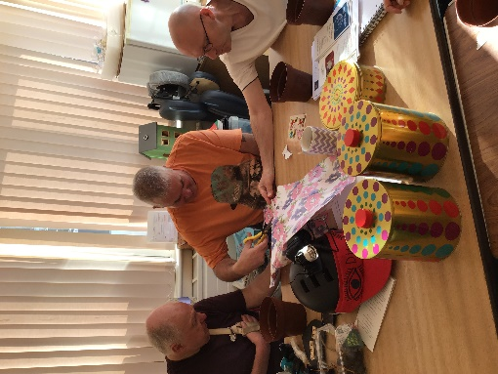
Art sessions, These have been delivered every week, with service users dipping in and out when they were interested In the activity that was taken place.
Sessions were planned and themed according to the time of year. Many of the activities included items that could be made and given to family members as gifts. The group began to make extra items that could be sold to raise funds by selling at the Project Christmas market.
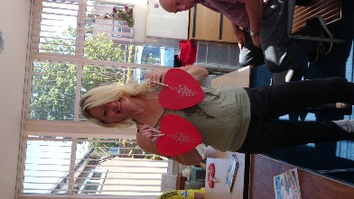
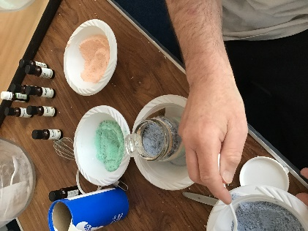
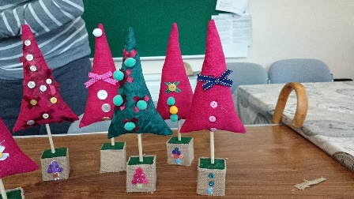

Time for Change – January
Is a report produced by the UK All-Party Parliamentary Group on Acquired Brain Injury. It covers the following areas and how changes in policy and recommendations in these areas are need to ensure neuro rehabilitation is available to all.
Time for Change | Neurorehabilitation
Education | Criminal Justice
Sports -related  Concussion | Welfare Rights

We held an event for members, local councillors, the Deputy Mayor David Snowdon and Sunderland MPS.
[See website for images.] https://www.headwaywearside.org.uk/
Cooking with Julie.
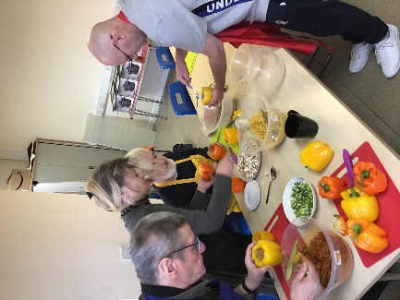
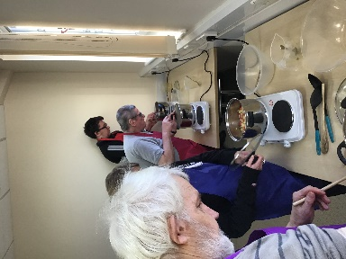
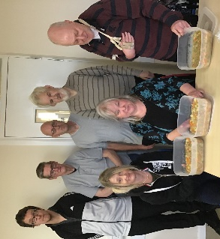
A small group took part in a cooking programme. This was a pilot project and was based at the Salvation Army. The group followed the Victory Programme with recipes such as vegetable mince and dumplings, pasta, chicken and vegetable curry, They also decorated Christmas treats.
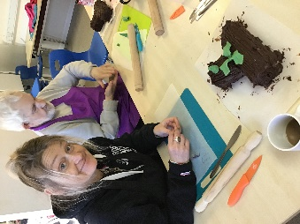
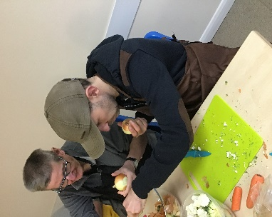

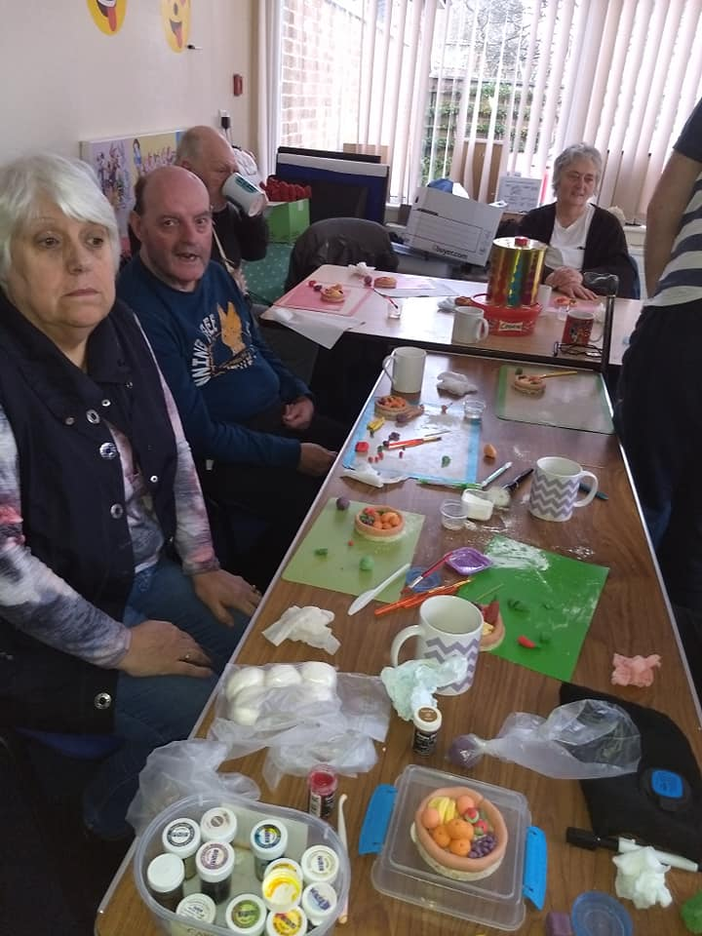
WEA Workers Education Association
Working in partnership courses have included Sweet treats and Sugar Craft. A group have 10 have completed two courses over the year learning a new range of skills including using piping nozzles, creating chocolate treats, and creating their own creations and cake topper decorations from sugar paste.

Look ahead in the North
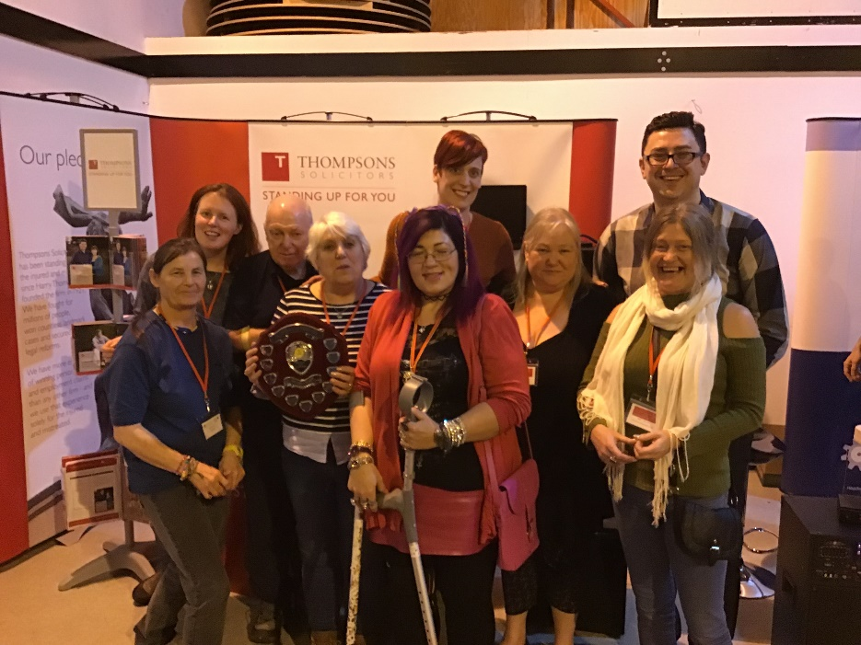
This is a yearly residential held at the Calvert Trust at Keilder. Members of Headway groups and branches attend for a fun packed weekend with outdoor activities, arts and crafts, swimming, music, disco, quiz night, our very own talent show Lans got Talent and so much more. It is an opportunity for our members to make new friends and create stronger bonds with each other. [check out loads of pictures on the Gallery Page ]
Headway Wearside Winners of the Steven McAleese Annual Memorial Quiz 2019.

Art Champions
A call was sent across Sunderland City to find ART champions, People who liked art, knew something or nothing but had an interest and would delve into the world of contemporary and modern art. Charmaine won one of those places, supported by Kim. Sunderland Museum and winter gardens recruited a group of local residents to become Art Champions and introduced the group to visits, knowledge, and friendships.

In your Words
S a male aged 45 + was asked “what you enjoy most about the project ?”
I enjoy going to city space. [the gym] I can’t get to it on the bus by myself just yet so having the transport for me to get there is brilliant, going to the gym helps with my movement and exercise but it also makes me feel like I can achieve something. I set goals and then can do them. There is always someone there to help me. I have made many friends now and because of them I went to Look ahead in the North
When asked why this year? “it meant I could go with my friends with others that go to the gym , If I got lost or didn’t know what to do I know I would have someone there. it was hard to make my family see the benefit of going. But my niece[carer] said she had also enjoyed it so much that she wanted us to go again next year. I achieved things I never thought I would be able to do .without Headway friends and staff I would not go out of the house except to hospital visits.

C a female aged 40+ was asked “what do you come to Headway Wearside.”
“ I now have some friends, I need to come here, I get all my stuff sorted out and need someone to keep an eye on me as im not very good at looking after things for myself. I am only now noticing how useless I have become and how much help I need. If I didn’t come to the project I wouldn’t see anyone, other than one person when I do see her.
I have started going to the football matches with one of the other people that attend the centre. It doesn’t cost me as my friend has a season ticket holder and likes someone to be with him .
Some of the people I met in the group also have been to my house for a cuppa, it was a good laugh. My new friends were surprised at my flat as I don’t live in “a good area” they thought it wouldn’t be nice inside. But I do keep it nice and it has been painted.
I also go to their houses sometimes, I have become friends with one of the families and they have even taken me to their caravan with their daughters and grandchildren.
I couldn’t afford to go on holiday and couldn’t go on my own as I would get lost as I cant remember too well since the stroke. and it was great to be away, we went for some walks along the beach. Something I would not be able to do by myself. It was good to be part of the family again.

J a male aged 45+ was asked “What do you do and why do you come to the activities?”
“I meet my friends and get information. I have learnt about energy and how to read my electricity bills. I had help with my benefit claims and help to complete my pip form. I can talk about my problems in the group and there is someone there to help me or has been through the same things as me. When I have problems they have been helped and sorted. We should call you [staff] the equalizer and problem solver.”
Yes we come here and can hire the “H” team.
What is that? “ The helpful Headway team.”

A female carer whose husband has an ABI “what are the benefits for you?”
The benefit I get is we are not on top of each other, he has his time and I now have my free time to do what I want to do and to relax. I am not so stressed everyday like I used to be before he came to the groups.
We try to communicate better as he tries to tell me what he has done when he is at the centre.
He has more of a life now than he has had the last 23 years since his illness affected him and he was no longer able to work.
I went to one of the social afternoons and met another brain injury survivor there it was like we had known each other for years. it was like there was a spark. We became friends instantly
I was talking to my husband who attends the group about meeting this lady. My family have also been instantly drawn to her and welcomed her into our lives with no judgements or pre conceived ideas.
AS time has went on the love for this lady has grown and the girls and my grandkids just love her so much.
My husband likes to know that I take an interest in what he is doing, I now also help with planning some of the events and activities for the group.
My husband enjoys the fact that he now has friends that can come to the house who has gone through a similar experience to himself.

Achievements
It is not only the delivery of the activities that is important but the face to face support that individuals receive during a crises or ongoing daily living problem. This includes lots of issues such as loss of benefits, difficulty in accessing health services. Problems sorting utilities or equipment.
We have delivered the following sessions over the last year
117 gym sessions [with accessible transport] at Sunderland University City Space.
24 Relaxation sessions with Klaire from Natural Selection Therapies
12 carers 1-1/group meetings /support
45 social support sessions/art with Julies ART
4 planning sessions
6 Social outings for Meals, this includes the Christmas lunch and
Transport to 39 gym Sessions
1 Residential Weekend at the Calvert Trust for 14 members
2 trips to London, Art Champion and Brain Injury Support Debate

Activities have been accessed 1460 times. Not including telephone support

The support time given and activities engaged with is different for each individual, the time someone accesses the service on a monthly basis depends upon how many activities they join in with or how much face to face or telephone support has been given. For some the range has been between 2 hours a month to 108 hours in a month. With many of our members accessing 12 hours a week on average.

Telephone support is available to everyone, non members including brain injury survivors/carers and professionals. We have not included time allocated to these calls as this is part of the wider support we offer within the community. Often calls are for information for next steps rehabilitation and social engagement. A high volume of calls are regarding queries with financial welfare.

Just to say thank you
The Trustees and staff at Headway Wearside would just like to thank all of our funders and supporters
- Boxing Day Dippers
- Great North Runners
- CABIS Team
- Sunderland Clinical Commissioning Group
- Peoples Health Trust
- Cumbria, Northumberland Tyne and Wear NHS Trust [CABIS]
- Washington Area Committee
- West Area Committee

We would also like to thank our partners, supporters, organisations and staff that we have worked with during 2018/19
Burnetts Solicitors
Holistic Case Management
EMG Solicitors
JSP LTD
St Mary and St Peters Community Project
Sunderland University City Space
Headway Uk
Ukabif - UK Brain Injury Forum
Robert Whitelaw
Glenn Kirby
Klaire Ferry
Julie Foster
MBC
Washington Millennium Centre
WEA
Sharon Hodgson
Bridgett Phillipson
Julie Elliot

